Imprint Corner Workshop

Indigo & Shibori Dyeing

Indigo
Indigo dye is sold in a powder form. The indigo power needs to be dissolved in water and fermented in a vat. Indigo requires a reduced oxygen environment to bond with the natural fibres (e.g. linen cotton, hemp, silk, wool), therefore we create a indigo dye vat.
The various Indigo plants (endemic to their global regions) from the pea family. In order to make indigo dye, the leaves of the indigo plant are used. The leaves are processed using traditional techniques including fermentation and reduction to create an indigo powder.

Indigo Recipe

Recipe for dyeing 500g fabric
- 20-25gms Natural Indigo (or 15gms Synthetic Indigo)
- 160gms Soda Ash
- 80 gms 25% Sodium Hydrosulphite

Starting/Creating the Indigo VAT

Instructions:
Prepare the Indigo/Soda Ash Solution
- Carefully dissolve Soda Ash in 500-600mls of boiling water
- Dissolve the Indigo powder in little hot water, Make a paste
- Slowly add the Soda Ash solution and make sure they are thoroughly mixed. (This solution is strongly alkaline: Avoid getting solution on your skin.) Note: by applying the reducing agent which does the opposite to the oxidizing effect
Prepare the dyebath
- Prepare the dyebath with approx. 6Lltrs of hot water.
- Stir Dye/Soda Ash solution gently into dyebath.
- Sprinkle 80gms Sodium Hydrosulphite over the surface of the vat, stir gently, cover and let it stand until the dye is completely vatted out. By covering the dyebath, you avoid too much oxidisation.
When the dyebath is ready to use, it should be a clear greenish yellow colour and have bronzy bubbles on the surface. If the dyebath is till blue and cloudy, the dye is not dissolved properly and you will need to add a little more Hydrosulphite.

DYEING THE FABRIC
Before dyeing the fabric, make sure the Indigo is completely ‘reduced’ by dipping a sample of the fabric or paper into the vat. It should come out of the dyebath greenish yellow and then turn blue when exposed to the air. The oxidization turns the fabric from a green/yellow to blue. No mordent to bond the dye is required.
Try keep the vat at 50c, lower the fabric into the dyebath and leave it there for 2mins. Remove from the dyebath, squeeze out excess dye and allow it to OXIDISE. To darken the shade re-dip the dyeing for a further 2 minutes or leave it longer. Check your dyebath to make sure it is still in solution and if you notice it’s going greenish/blue, sprinkle a little more Hydros on the surface to keep it vatted out. Avoid the ‘flower’ bubbles, these will leave blotches on your fabric. After you have oxidised to your fabric and you’re happy with the colour, wash well in hot soapy water to remove excess dye and chemicals.
- The intensity of the blue depends on the number of dips.
- You must allow the oxidise between dips
- Remove existing dye into a second container
- Between dips; rinse until the water is clear

Tips for dyeing;
- Bubbles on the surface of the vat means the vat is activated
- Carefully dip the fabrics into the vat (to reduce the drama on the surface of the vat, limiting oxygen)
- Gently remove fabric from vat
- Gently remove dye from the fabric
- Use wet fabric before dipping
- Initially your vat will produce darker blue >> over time, more fabric reduced dyeing pigment
- Colour changes from the vat in oxygen > Yellow/Green to Teal to Blue
- You can redip the fabric for darker colour
- You can leave overnight before rinsing for a stronger colour
- Lightweight fabrics are easier to dye
- Only use natural fibres

Maintaining an INDIGO VAT
If you feel there is still unused dye left in the dyebath after you have finished doing your INDIGO dyeing – you can save this and revitalise it by adding more chemicals next time you use it. Remember that the dyebath needs to be a clear greenish yellow to be viable and if it has stood for any length of time, the dye will have reverted to its insoluble state. Covering the dyebath while it isn’t in use will help keep the dye in solution, but before you reuse it, test the bath with some white paper to determine if it needs to be re energised.
If the solution is clear and green you may not need to add anything but it will be most likely you need to add more Soda Ash and Hydros. Dissolve 75gms Soda Ash in boiling water and add this to the dyebath, then sprinkle 40gms Hydros onto the surface of the dyebath and stir gently until it vats out. You may also need to heat the dyebath to 60c for this process to be successful. You can do this by adding boiling water to the vat or by using a heat source like an element. Dye technology is complex and while we attempt to simplify our methods as much as possible, results may vary depending on the Indigo you’ve used, the ambient temperature and the temperature of the dyebath. Quality and age of chemicals can also be a factor in the success of your dyeing

Indigo Bath/Vat
Different intensities of the blue on the fabric are obtained by number of times the fabric is dipped into the indigo vat.

Oxidation
Oxygen bonds the colour like an apple turning brown with oxygen
Molecules of dye, oxidized it turns blue
Indigo likes alkaline, we use soda ash as dyeing medium. We reduce the oxygen using sodium hydrosulphite.

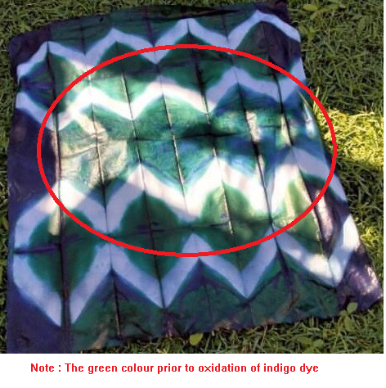

Another Indigo Dyeing Recipe
- one part natural indigo (20g)
- two parts lime (40g) ( alkaline agent)
- three parts fructose syrup or crystals (60g)
same procedure as with the above recipe

The fabric
When choosing fabric or clothing, it’s important that made of natural fibres. Cotton, wool, silk, hemp or linen work best. Lightweight is best. I also like to pre-wash my fabric before dyeing. Additionally I like to soak the fabric prior to dyeing.

Equipment you’ll need:

Indigo dye vat
- an indigo dye kit
- natural fiber clothing or fabric
- 9-10 litre buckets (one with lid)
- rubber gloves
- scissors
- long wooden stick/spoon for stirring
- drop cloth

Shibori tools
- shibori shapes e.g. square, circle, wood, craft paddle sticks, pegs, stones
- rubber bands
- string/cord
- a PVC pipe
- a long wooden stick

SHIBORI
Shibori is a Japanese term for several methods of dyeing cloth with a pattern by binding, stitching, folding, twisting, compressing it, or capping. Some of these methods are known in the West as tie-dye.
Itajime shibori is a shaped-resist technique. Traditionally, the cloth is sandwiched between two pieces of wood, which are held in place with string. The shapes prevent the dye from penetrating the fabric they cover.

Shibori folding the fabric

Shape-resist technique. To start, fold the fabric like an accordion. We fold the fabric to the size of the shape we are using.
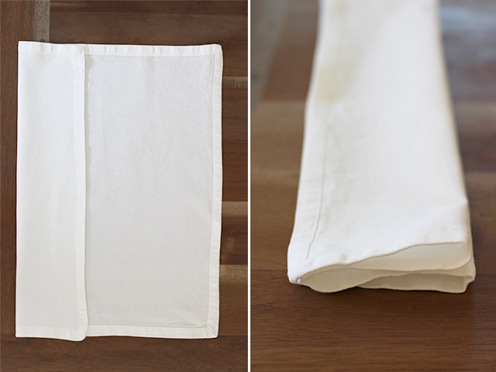  Figure 1 Fold the fabric over to the size of the shape. Fold all the fabric like a accordion | 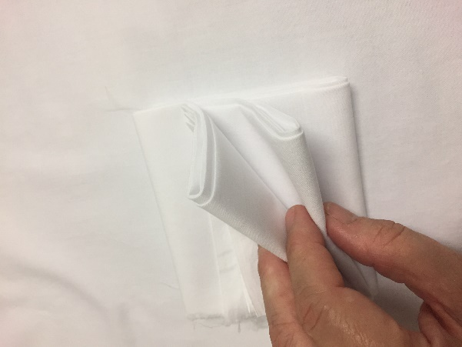  Figure 2 Fold the Fold it again in the other direction, in the accordion style
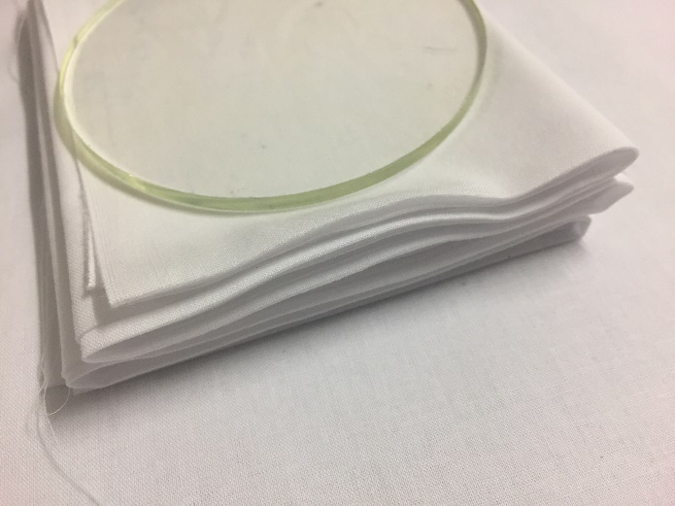  Figure 3 Prior to binding the shape to the fabric | Figure 4 Binding the fabric with string/rubber bands

Fold it again in the other direction – again, like an accordion. Place it between two pieces of plastic wood, or any flat shaped object, and bind it together with string or rubber bands. The shapes and rubber bands will prevent the dye from penetrating the fabric they cover. The larger the shape and the more rubber bands you use, the more white you will see. The smaller the shape and fewer rubber bands you use, the more indigo you will see

Shibori : pole-wrapping technique.
It starts by wrapping fabric around a plastic PVC pipe at a diagonal. Once the fabric is wrapped tight, I put a rubber band (or you can tie a piece of string) at the base of the pipe.
Then you wrap the twine around the fabric (I tie a piece of string at the base). After 6-7 wraps around the pipe, scrunch the fabric down. Give the twine a strong tug to tighten. Tightening before scrunching will make it more difficult to control and move the fabric. I wrap the string numerous times around the pipe.

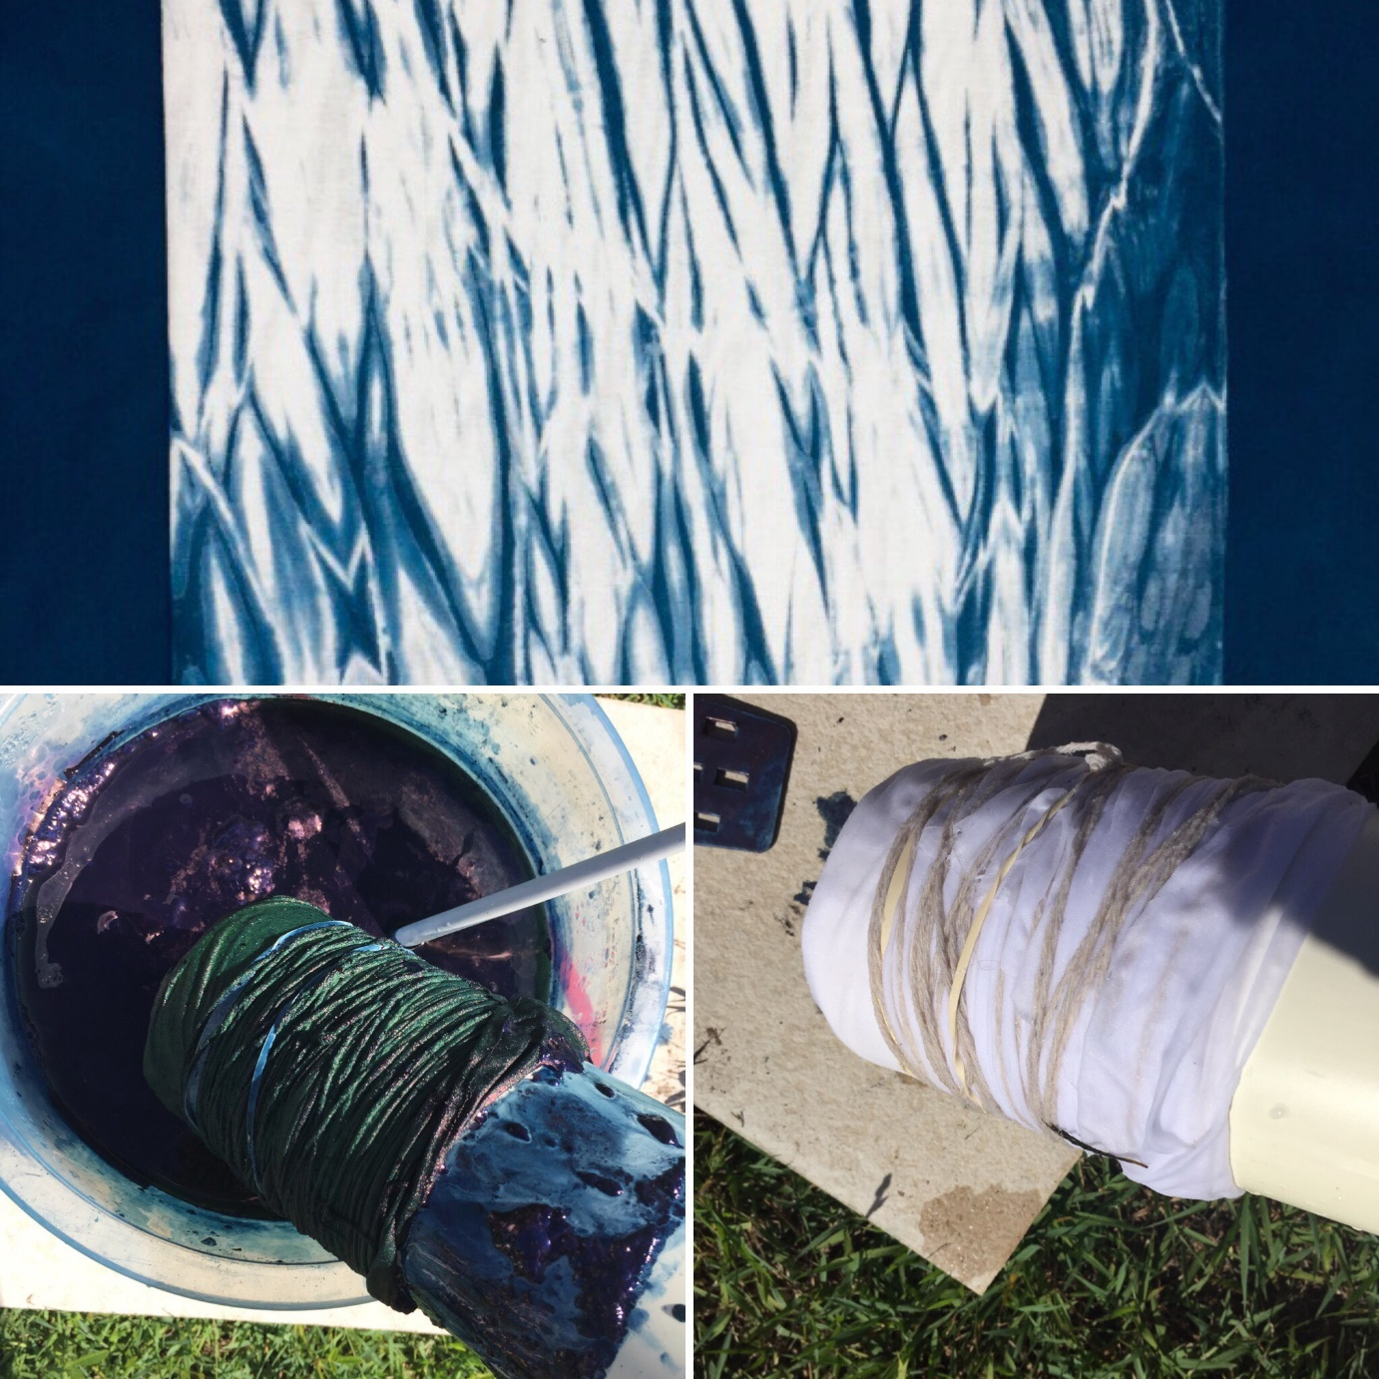

Pleat and bind technique.
It involves binding the fabric (with string, rubber bands, zip ties) in very close sections, which results in several spider like (or sun boasts) designs. This is just one of many ways to experiment with this technique. Start by folding the fabric into an accordion. Pinch and bind into equal sections.
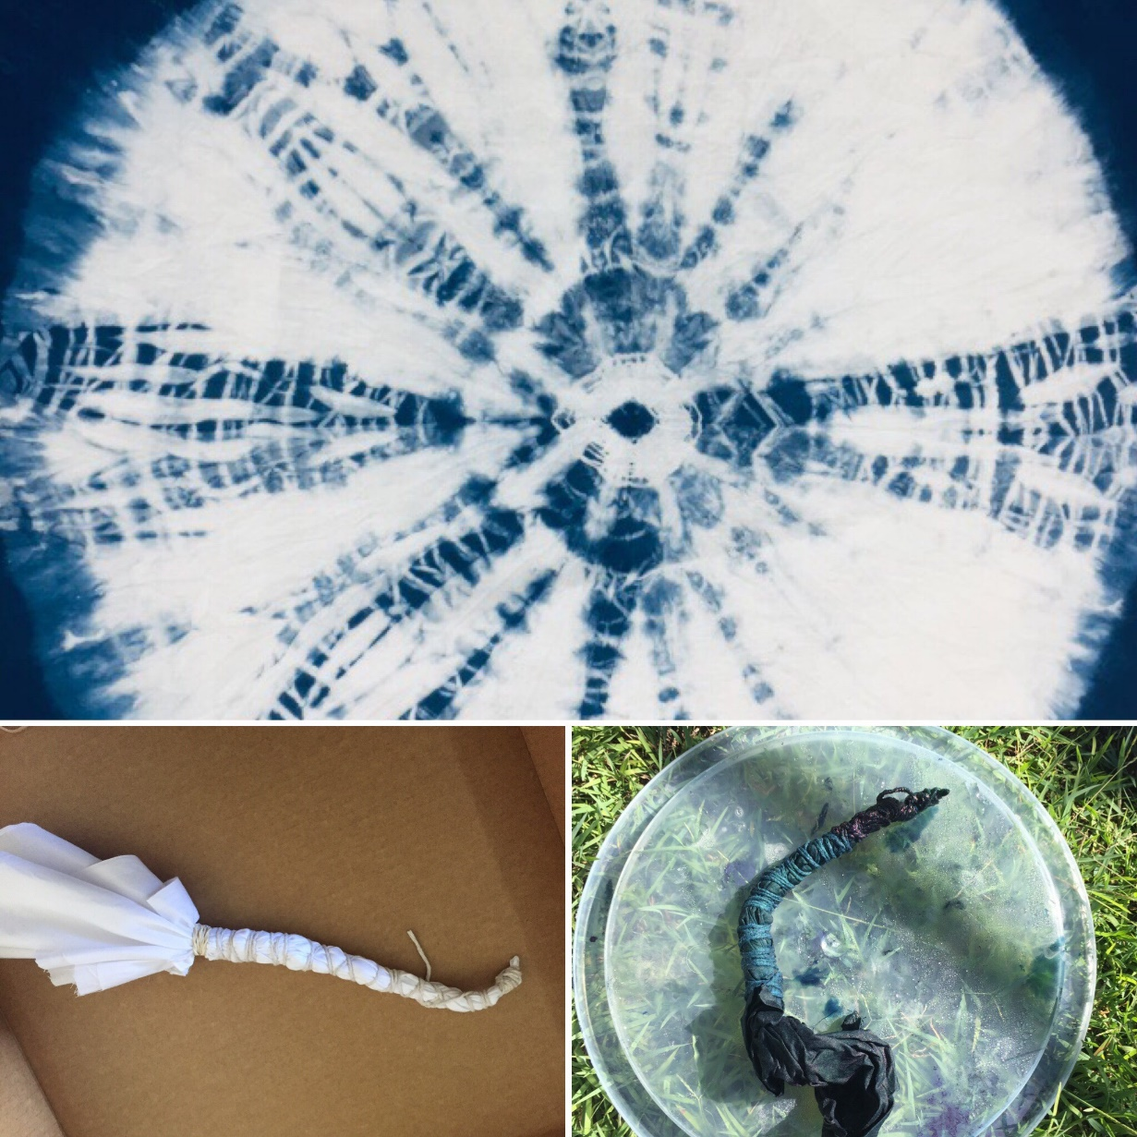

Using stones and pegs another approach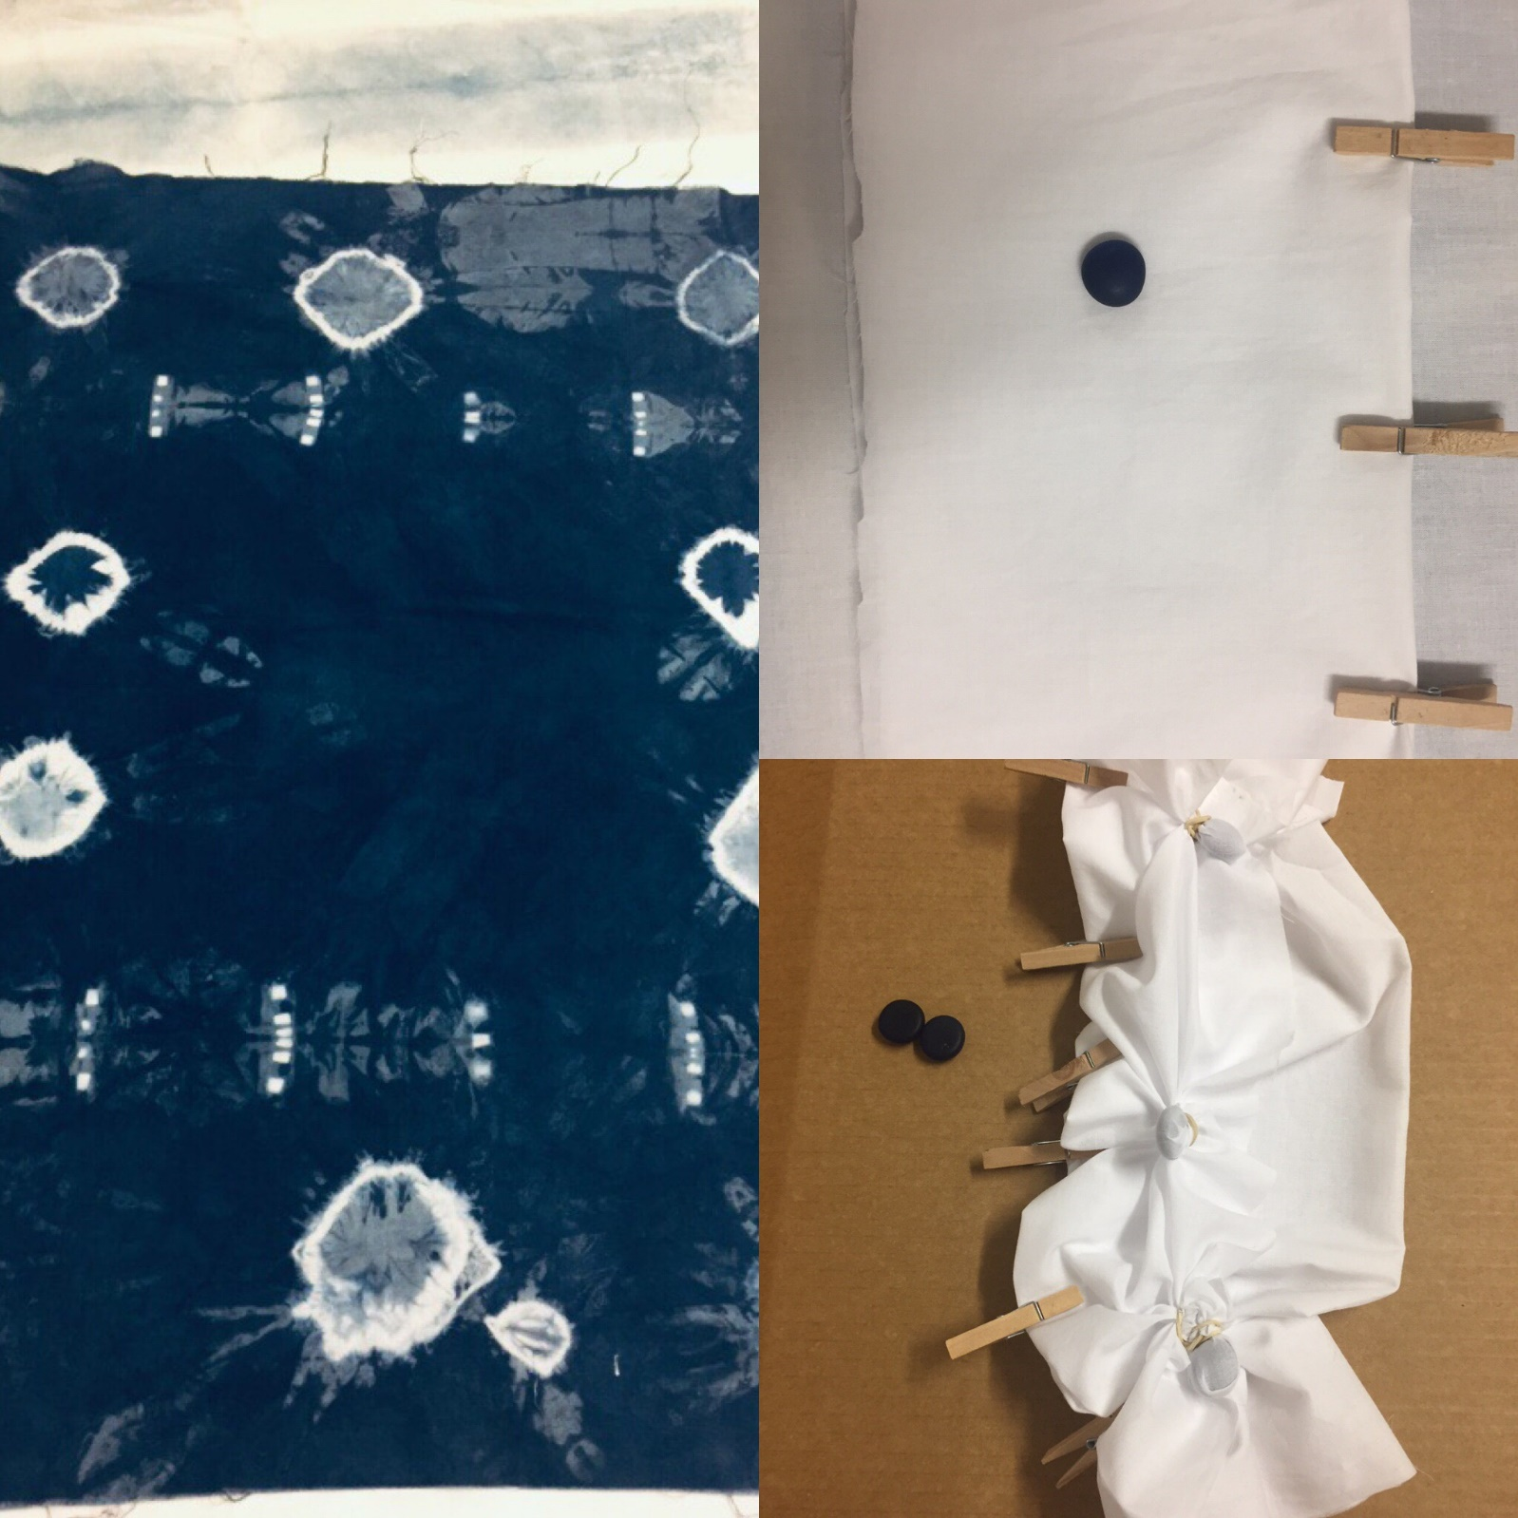

Stitch resist technique

Steps
- I draw a design (e.g. fish, leave, circle, flower) with a sewing pencil on the fabric
- With a needle & thread (double if the thread is thin) I saw around the design.
- I pull the thread tight. And tie off the ends. Then you are ready to dye

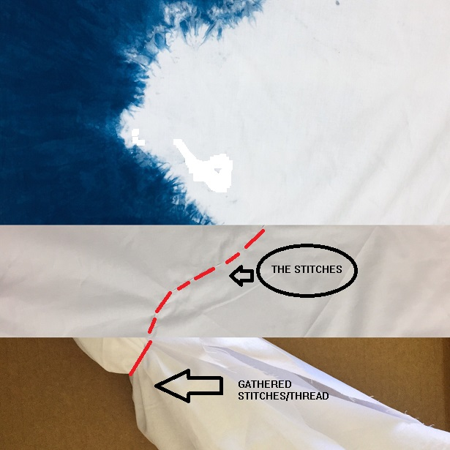
Figure 5 This is a sample of stitched design. Its a long scarf with one half dyed and the other half is white

SHIBORI Ideas

Sticks to create different lines. Both on an angle and straight
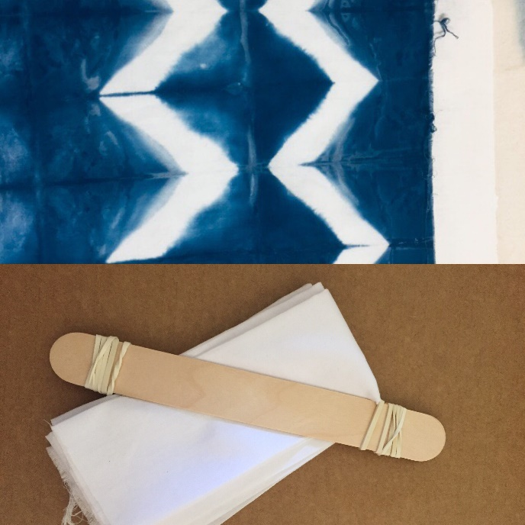

Different shibori shapes e.g. squares, triangles & hexagon.

